

**[EVENT TITLE]**

**NOTICE OF RACE & SAILING INSTRUCTIONS (NoR/SI)**

**To be supplemented by Local Sailing Instructions (LSI)**

[DATE OF FIRST VERSION] Initial Version

[DATE OF CURRENT VERSION] Summary of Amendments

**1 DATE AND VENUE**

|  |  |  |
| --- | --- | --- |
| **Venue** | **Organizing Authority** | **Dates** |
| [VENUE]  [CITY]  [COUNTRY]  [GPS COORDINATES OF VENUE] | [NAME OF ORGANIZING AUTHORITY UNDER RRS 89.1] | [REGISTRATION DATE]  -  [PRIZE GIVING DATE] |

If the event is cancelled, any paid entry fees will be refunded in full.  
The organizing authority will not be liable for any other expenses incurred.

**2 RULES**

2.1 The event is governed by the rules as defined in The Racing Rules of Sailing (RRS). Other documents under RRS Definition: Rule (g) are published on the IKA website, [LINK] and include:

2.1.1 [NP] [DP] [SP] The Equipment Regulations (ER);

2.1.2 [NP] [DP] [SP] The Support Team Regulations (including support person vessels) (STR); and

2.1.3 [NP] [DP] [SP] The Athlete Media Regulations (AMR)

2.1.4 [NP] Standard Penalties (SP)

2.2 RRS Appendix F applies.

2.3 For the Medal Series, World Sailing Appendix FMS Kiteboarding Medal Series available on the World sailing website ([www.sailing.org](http://www.sailing.org)), applies and changes a number of racing rules. The version that is current when the event begins will be published on the Official Notice Board.

2.3 For the Medal Series, Addendum FMR (Refereed Medal Series) applies and changes a number of racing rules. The version that is current when the event begins is published on the IKA website, [LINK]. It takes precedence over any conflicting rules.  
This changes RRS 63.5(c). Select one of the two options.

2.4 Local Sailing Instructions (LSI) will be published no later than on the day before the first warning signal and may change or supplement rules in these NoR/SIs. If there is a conflict between the NOR/SI and the LSI, the LSI will take precedence. This changes RRS 63.5(c).

2.5 In all rules governing the event;

2.5.1 [SP] denotes a rule for which a standard penalty may be applied by the race committee or technical committee without a hearing. Additional rules marked [SP] are listed in NoR/SI 18. This changes RRS A5.1.

2.5.2 [NP] denotes a rule that shall not be grounds for protest by a kiteboard and for which the protest committee may refuse to hold a hearing. Additional rules marked [NP] are listed in NoR/SI 18. This changes RRS 60.1 and 63.2(a).

2.7 If there is a conflict between languages the English text will take precedence.

2.8 Changed and added Rules:

2.8.1 Add rule RRS 61.4(b)(6): the action of a drone, or any other flying device.

2.8.2 Actions by event officials to implement medical pandemic guidance, protocols, or legislation, even if they later prove to have been unnecessary, will not be grounds for redress. This changes RRS 61.4(b).

2.8.3 From 1 hour before the scheduled warning signal of the first race until the end of the protest time of the last race of the event, a kiteboard may change her kite but only in the launching area.

2.8.4 For Medal Series Races only:

Races will be started with a black flag as preparatory signal.  
When at the starting signal the race committee observes a kiteboard in the triangle formed by the ends of the starting line and the first mark, the race committee will signal a general recall. This changes RRS 29.2.

**3 EVENTS, QUOTAS AND ELIGIBILITY**

Optional (and renumber accordingly for Olympic qualification events)

3.1 Only competitors registered by a Member National Authority (MNA) in good standing with World Sailing are eligible to enter the event.

3.1 There will be competition in the following events, classes and divisions:

|  |  |  |  |  |
| --- | --- | --- | --- | --- |
| **Event** | **Class** | **Division** | **Max. Quota** | **Min. Quota** |
| **Men’s Individual** | Formula Kite | [OPEN OR U21] | [QUOTA] | [QUOTA] |
| **Women’s Individual** | Formula Kite | [OPEN OR U21] | [QUOTA] | [QUOTA] |
| **Boy’s Individual** | KiteFoil Open | [U15] | [QUOTA] | [QUOTA] |
| **Girl’s Individual** | KiteFoil Open | [U15] | [QUOTA] | [QUOTA] |

U21: born 2005 or after  
U19: born 2007 or after

U17: born 2009 or after – for 2025

U15: born 2011 or after – for 2025

3.1.1 Exceptions to the maximum quota may be made at the discretion of the organizing authority.

3.1.2 If less than five (5) competitors are registered in an event or division, they may be combined with the next higher age division and/or the other gender.

3.1.3 The Organizing Authority may cancel an event if the minimum number of entries has not been confirmed and paid 14 days before the on-site registration day of the event. Competitors will be notified of event cancellation by email and posting on the IKA website. Entry fees will be refunded.

3.2 World Sailing Eligibility in accordance with World Sailing Regulation 19 is required of all athletes.

3.3 Each athlete shall be registered as a World Sailing Sailor on the World Sailing website: <https://www.sailing.org/sailors/world-sailing-profile/>

3.4 On 1 March 2022 World Sailing published the following recommendations in reaction to the situation in Ukraine: <https://www.sailing.org/2022/03/01/world-sailing-statement-6/>. To help preserve the integrity and safety of the event, entries shall not be open to competitors and support persons holding only Russian or Belarussian nationality. The Organizing Authority may amend this rule following any further World Sailing decisions on the situation with Russia and Belarus.

3.5 Each athlete shall be a national of the country they represent (see World Sailing Eligibility Code). Each athlete shall upload proof of their nationality to the online registration system.

3.6 Each competitor shall be a member of an IKA member (National Class Association) of either his/her nationality or his/her country of permanent residence. Evidence of membership shall be presented at registration if requested. If no current member exists, the competitor shall become individual member of IKA. Membership formalities may be completed on site.

**4 ENTRY, REGISTRATION AND FEES**

Optional (and renumber accordingly for Olympic qualification events)

4.1 The Qualification System for the event shall apply and confirms the quota process and entry deadlines. The Qualification System is published on the official notice board.

4.2 Applications for quota places in accordance with the Qualification System shall be made through the online registration system at [LINK TO REGISTRATION PAGE].

4.3 MNAs with entrants shall register their main point of contact and team leader through the online registration system.

4.1 Competitor registrations shall be made through [LINK TO REGISTRATION PAGE]. Late registrations may be accepted during on-site registration.

4.2 Entries will be accepted on a first come-first served basis. [OR DESCRIBE OTHER MEANS OF ENTRY ALLOCATION]

4.3 Registration fees per competitor are as follows (all plus credit card fees) and are not refundable except if the event is cancelled:

|  |  |  |  |  |
| --- | --- | --- | --- | --- |
| Early Bird  Entry Fee | Early Bird Deadline | Regular Entry Fee | Regular Entry Deadline | Late  Entry Fee |
| [FEE] | [DATE] | [FEE] | [DATE] | [FEE] |

4.4 Competitors shall provide the following documentation prior to completing registration formalities on site:

* Evidence of national class association membership;
* Proof of nationality;
* Proof of age;
* World Sailor ID;
* Parental/legal guardian consent - for those under the age of 18;
* Medical Treatment Permission - for those under the age of 18 or on their parent’s medical insurance policy
* [OR DESCRIBE OTHER REQUIREMENTS AS NEEDED]

4.5 Support Teams

4.5.1 Support persons, support person vessels and team leaders shall be registered with the Local Organizing Authority and comply with local legislation and the Support Team Regulations. The Local Organizing Authority may refuse registrations or accept later registrations at their discretion.

4.5.2 The Organizing Authority may, at its discretion refuse support person vessels entry to the venue if they are deemed unsuitable. Generally, open vessels less than 7.5 metres in length, having minimum or no superstructure (cabin, coach house, bridge etc.), will be considered suitable.

4.5.3 The registration fee for support persons and support vessels are as follows:

|  |  |
| --- | --- |
| **Support Person Type** | **Entry Fee** |
| **On-Water Support Persons (incl. benefits as for competitors)** | 0 EUR |
| **Other Support Persons (incl. benefits as for competitors)** | 50 EUR |

The amount shall be paid during on-site registration.

4.5.4 Support persons shall provide the following documentation prior to completing registration formalities on site:

* List of athletes or MNAs supported;
* Boat Driving License (if applicable); and

[OR DESCRIBE OTHER REQUIREMENTS AS NEEDED]

4.6 [NP] [SP] [DP] Competitors, support persons and team leaders shall personally sign the registration form at the Race Office at the specified time.

4.7 An entry is not complete until payment has been received and the kiteboard or support person has completed registration. Registration may include equipment and entry requirement checks.

**5 SCHEDULE**

5.1 The schedule will be as follows (all times are local):

|  |  |  |
| --- | --- | --- |
| **Date** | **Activity** | **Time** |
| **[DATE]** | Arrival, venue opens |  |
| **[DATE]** | On-Site Registration | [FROM-TO] |
| **[DATE]** | Equipment Inspection | [FROM-TO] |
|  | Practice Race | [TIME] |
|  | Equipment Inspection | [FROM-TO] |
|  | Profile Picture Photo Shoot (mandatory) | [FROM-TO] |
|  | Opening Ceremony / Welcome (tbc) | [TIME] |
| **[DATE FROM]– [DATE TO]** | Racing | See Addendum 2 |
| **[DATE]** | Prize Giving and Closing Ceremony | [TIME] |
| **[DATE]** | Departure, venue closes |  |

5.2 There will be a daily briefing for competitors and support persons / team leaders in the launching area 60 minutes before the first scheduled warning signal.

5.3 Addendum 2 shows the provisional race schedule, including the time of the first warning signal and the number of scheduled races.

5.4 Any change to Addendum 2 will be posted no later than 21:00 on the previous evening of any race affected.

5.5 The Race Committee may change the schedule to sail one race ahead of schedule. The Race Committee may schedule racing on a reserve day.

5.6 Not more than a total of 6 races per fleet will be sailed per day.

5.7 The Medal Series will not be scheduled on the same day as an Opening Series race for that event.

5.8 The first warning signal for the first race on [DATE] will not be before [TIME OF FIRST WARNING SIGNAL].

5.9 On the last scheduled day of racing no warning signal will be made after [TIME OF LAST WARNING SIGNAL]

1. **FORMAT AND SCORING**

6.1 One race for all fleets is required to be completed to constitute an event.

6.2 The format for each event will be an Opening Series followed by:

a) a Golden Ticket Race and Medal Series when there are more than 10 entries in an event.

b) a Medal Series when there are 10 and less entries in an event.

6.2.1 Not more than 20 races will be sailed in the Opening Series.

6.2.2 Addendum 4 describes the details of the Format.

[OR SINGLE SERIES, SEE ADDENDUM 5]

6.2.3 The format may be changed to reflect World Sailing decisions on the format for the LA 2028 Olympic Games.

6.3 Events may be split into groups when there are more than 30 entries in an event. Events will be split into groups when there are more than 40 entries in an event.

6.4 A Medal Series will be sailed if five or more Opening Series races have been completed over a minimum of two days on which racing took place. Otherwise, the Opening Series will be extended.

6.5 Division rankings (if any) will be established by simple extraction from the overall standings.

6.6 To request correction of an alleged error in posted race or series results, a kiteboard may submit a scoring enquiry through the online platform.

**7 NOT IN USE**

**8 COURSES AND RACING AREAS**

8.1 The diagrams in Addendum 1 show the courses, the course designations, the approximate angles between legs, the order in which marks are to be passed, and the side on which each mark is to be left.

8.2 No later than the warning signal, the race committee starting vessel will display the course to be sailed.

8.3 If mark P is not set, it shall be disregarded.

8.4 Courses will not be shortened. This changes RRS 32.

8.5 Courses will not be changed. This changes RRS 33.

8.6 Addendum 3 shows the location of the venue and the course area.

**9 STARTING AND FINISHING**

9.1 To alert kiteboards that a race or sequence of races will begin soon, the starting line flag will be displayed with one sound at least 2 minutes before a warning signal is made.

9.2 The warning signal for each succeeding race will be made as soon as practicable.

9.3 Except for the Golden Ticket Race, the starting line will be between a staff displaying an orange flag on the race committee vessel and either:

a) the course side of the port-end inflatable mark, or

b) a staff displaying an orange flag on the race committee vessel on the port end.

9.4 For the Golden Ticket race, a Rabbit start will be used:

9.4.1 at the starting signal, a vessel displaying an orange chequered starting line flag (the Rabbit) will proceed at high and constant speed from the starting mark to the race committee signal vessel. Kiteboards shall start between the course side of the starting mark and the stern of the Rabbit.

9.4.2 A kiteboard shall not sail between the race committee signal vessel and the Rabbit from one minute before her starting signal until she starts. If a kiteboard breaks this rule and is identified, she shall be disqualified without a hearing, even if the race is restarted or resailed. This changes RRS 35, 36 and A5.1.

9.5 A kiteboard starting later than 1 minute after her starting signal will be scored Did Not Start. This changes RRS A5.1 and A5.2

9.6 [NP] [DP] When a starting sequence is in progress, kiteboards whose warning signal has not been made shall avoid the starting area. The starting area is defined as an area 300 meters from the starting line and marks in all directions.

9.7 The finishing line will be between a staff displaying a blue flag and the course side of the nearby finishing mark.

9.8 [NP] [DP] Kiteboards that have finished shall sail clear of the finish area.

**10 TIME LIMITS AND TARGET TIMES**

10.1 Time limits and target times, in minutes, are as follows:

|  |  |  |  |  |
| --- | --- | --- | --- | --- |
|  | **Target Time** | **Race Time Limit** | **Mark 1 Time Limit** | **Finishing**  **Window** |
| **Opening Series** | 12 | 24 | 6 | 6 |
| **Golden Ticket** | 24 | 48 | N/A | 24 |
| **Medal Series** | 7 | 14 | 4 | 3 |

10.2 If no kiteboard has passed Mark 1 within the Mark 1 time limit, the race will be abandoned.

10.3 Kiteboards not finishing within the Finish Time Window (time after the first kiteboard sails the course) will be scored Did not Finish without a hearing. This changes RRS 35, A5.1 and A5.2

**11 [NP] [DP] [SP] IDENTIFICATION**

**AND ADVERTISING**

11.1 When provided by the organizing authority, kiteboards or competitors shall carry, display or wear the following as instructed:

11.1.1 Competition bibs for all competitors with an individually assigned competition number, worn as intended over all other clothing and equipment at any time when afloat;

11.1.2 Event leader bibs, worn as intended over all other clothing and equipment at any time when afloat;

11.1.3 Event advertising and Look of the event;

11.1.4 Cameras, camera dummies, sound and other media equipment;

11.1.5 Tracking, timing and electronic umpire system equipment.

11.2 Kiteboards shall not display advertising from previous events.

**12 COMMUNICATION**

12.1 The event management platform, including the official notice board will be online at

[LINK TO OFFICIAL NOTICE BOARD ONLINE]

12.1.1 Complementary information may be posted on a notice board in the venue.

12.1.2 Informal communication may be sent through a [MESSENGER] group at [LINK]

12.2 The location of the official flagpole will be described in the LSI.

12.3 When flag AP is displayed ashore,

a) for the Opening Series and the Golden Ticket Race, ‘1 minute’ is replaced with ‘not less than 20 minutes’ in the race signal AP. This changes RRS Race Signals.

b) For the Medal Series, ‘1 minute’ is replaced with ‘not less than 10 minutes’ in the race signal AP. This changes RRS Race Signals.

12.4 Flag K displayed with two sounds means ‘Kiteboards are given time to change their equipment. Races not started are postponed. The warning signal will be made not less than 10 minutes after the flag is displayed.’

12.5 [SP][DP][NP] Flag G:

(a) displayed ashore with two sounds means ‘No kiteboard shall go afloat until this signal is removed (with one long sound). The warning signal will be made not less than 20 minutes (10 minutes for the Medal Series) after removal.’

(b) displayed afloat means ‘Kiteboards not racing shall return ashore as soon as reasonably possible.'

12.6 A signal displayed at the finish vessel applies only to the fleet that is finishing. This changes RRS Race Signals preamble.

12.7 While racing, except in an emergency or when using equipment provided by the race committee or Organising Authority, a kiteboard shall not make voice, radio or data transmissions and shall not receive voice, radio or data communication that is not available to all kiteboards. This restriction also applies to mobile telephones.

12.8 For the Medal Series, the race committee will display the flight designation before the warning signal.

**13 CHANGES TO NOTICE OF RACE AND SAILING INSTRUCTIONS**

Any change to the NoR/SI and the LSI will be posted 30 minutes before it will take effect.

**14 [NP] [DP] [SP] SAFETY**

**REGULATIONS**

When Flag G is displayed ashore, competitors returning ashore shall either personally check in at the official flag pole where the flag is displayed, or be reported as safe by their support persons.

**15 [NP] [DP] CODE OF CONDUCT**

15.1 Competitors and support persons shall:

15.1.1 comply with any reasonable request from an event official. Non-compliance may be misconduct.

15.1.2 not in any way interfere with the functionality of supplied media or timing equipment.

15.2 Kiteboards not racing shall remain clear of areas where kiteboards are racing and any official boats.

**16 [NP] [DP] [SP] EQUIPMENT   
INSPECTION AND REPLACEMENT**

16.1 Competitors shall submit a complete and correct Equipment Registration Form before 1900 on the day before the first scheduled equipment inspection through the event management platform [or describe other process]. Exceptions may be authorized by the Event Technical Committee.

16.2 Kiteboards shall be available for inspection from the time specified in the schedule.

16.3 Information on equipment to be inspected on each scheduled equipment inspection day will be published before 21:00 hours on the day before the first scheduled equipment inspection day, and after racing each day within the protest time limit. Competitors shall present the equipment to be inspected at the time published.

16.4 The fact that race officials may conduct inspections of a kiteboard does not reduce the responsibilities of each competitor set out in the rules.

16.5 Kiteboards are required to comply with RRS 78.1 and Event Equipment Rules from one hour before the first scheduled warning signal until the end of the protest time of the last race of the event.

16.6 Upon arriving ashore, a kiteboard may be instructed by a member of the Event Technical Committee to proceed immediately to a designated area for inspection.

16.7 Substitution of damaged or lost equipment will not be allowed unless authorized by the Event Technical Committee. Requests for substitution shall be made at the first reasonable opportunity through the event management platform. [or describe other process]

16.8 ER 3.5.(a)/(b) applies: (Note: the default as per class rules is that kites may be replaced with another kite from the same range, not necessarily an identical kite)

(a) Kites shall only be replaced with kites of the same brand, make, and size, or  
 [recommended for senior World and European Championships, Olympic Qualification  
 events, Olympic and major Regional Games]

(b) Kites shall only be replaced with a kite of the same size range.  
 [class rules default for all other competitions]

**17 INTERNATIONAL JURY AND  
 TECHNICAL COMMITTEE**

17.1 An international jury will be appointed in accordance with RRS 91(b). Its decisions will be final as provided in RRS 70.3.

17.2 An Event Technical Committee will be appointed in accordance with RRS 92.1.

**18 HEARING REQUESTS AND PENALTIES**

18.1 Hearing request forms are available through the event management platform and shall be lodged through it. [OR DESCRIBE AVAILABILITY OF PAPER FORMS].

18.2 The protest time limits is 30 minutes after the last kiteboard has finished the last race of the day or of the series for that fleet, or when AP over A, or N over A is displayed.

18.3 Notices will be posted within 15 minutes of the protest time limit to inform competitors of hearings in which they are parties or named as witnesses. Hearings will be held beginning at the time and location posted. Hearings may be scheduled to begin up to 15 minutes before the end of the protest time limit.

18.4 Penalties for breaches of the ER, STR, AMR, RRS 50, RRS 78.1, class rules, or rules in the NoR and SIs marked [DP] and [SP], should the case go to a hearing, are at the discretion of the protest committee.

18.5 For breaches of NoR/SI marked [SP], breaches of ER 2.3 and 2.4, or breaches of RRS 50 in conjunction with a class rule listed in the SP list, the race committee or technical committee may apply a standard penalty without a hearing to the race(s) closest in time to the incident. The scores of other kiteboards shall not be changed; therefore, two kiteboards may receive the same score. However, the race committee or technical committee may protest a kiteboard when they consider the standard penalty to be inappropriate. A kiteboard that has been penalized with a standard penalty can neither be protested for the same incident by another kiteboard nor can another kiteboard request redress for this race committee or technical committee action. This changes RRS 60.1, 61.1(a) and RRS A5.1.

18.6 A kiteboard may not protest a kiteboard for non-compliance with building specifications. The protest committee may refuse to hold a hearing when a kiteboard protests based on this rule. This changes RRS 60.1 and 63.2(a).

18.7 In RRS 61.3(b) and 63.7, "on the last scheduled day of racing" is replaced with "on the last day of the qualifying series, opening series and last scheduled day of racing".

18.8 For the Golden Ticket race, a kiteboard intending to protest or request redress shall additionally inform the race committee of her intention to protest as soon as practicable after she finishes or retires. This changes RRS 60.2 and 61.2.

**19 [DP] SUPPORT PERSONS INCLUDING  
SUPPORT PERSON VESSELS**

19.1 By registering as a support person, each such person agrees to be governed by the rules.

19.2 A support person vessel includes any vessel that is under the control or direction of a support person as defined in the RRS and also includes any person gathering data that may be used by a team or competitor.

19.2 Support person vessels shall display the 3-letter code of their World Sailing MNA at all times while afloat clearly visible from both sides of the vessel. The minimum height for the letters shall be 200 mm.

19.3 Limitations of equipment that may be carried and mandatory equipment that shall be carried on support person vessels will be detailed in the STR.

19.4 Except when participating in rescue operations as requested or instructed by the race committee, support person vessels shall remain in the area defined in the STR from the moment the orange flag is displayed and while kiteboards are racing.

19.5 A MNA, competitor, or support person shall not leave any device, piece of equipment, buoy, marker or similar item permanently in the water.

**20 [NP] [DP] PRIZES,   
VICTORY CEREMONY**

20.1 [DESCRIBE PRIZES FOR TOP X COMPETITORS]

20.2 [DESCRIBE MEDALS / DIPLOMA FOR TOP X COMPETITORS]

20.3 Rankings / Performance Certificates will be provided for age divisions with a minimum of 5 entries after the end of the competition:

U21: born 2005 or after  
U19: born 2007 or after

U17: born 2009 or after

U15: born 2011 or after

20.4 If a competitor who finished in the top 3 leaves the event before the conclusion of the victory ceremony or, if other competitor, leaves the venue before the day before the victory ceremony, the OA may exclude that competitor from the next Championship or impose any similar sanction.

20.5 The OA may reduce or remove a prize in the case of misconduct or refusal to comply with any reasonable request, including attendance at official functions.

**21 [NP] [DP] INSURANCE**

21.1 Each ‘person in charge’ (see RRS 46) shall confirm to hold a valid insurance certificate showing proof of third-party liability coverage.

21.2 Each support vessel shall have valid insurance including third party liability coverage of at least 500.000 EUR (or equivalent) per incident.

21.3 The Organizing Authority is not responsible for verifying the status or validity of certificates.

**22 DOPING CONTROL**

World Sailing rules and regulations concerning the use of banned methods and substances, which are contained in the World Sailing Anti-Doping Code apply. Drug testing may take place during the events.

**23 RISK STATEMENT**

23.1. In cases of force majeure or on grounds of administrative orders or for safety reasons, the organizing authority is entitled to make changes in the realization of the event or to cancel the event. This does not constitute any liability by the organizer towards the participant, if the reasons for the changes or the cancellation do not result from a wilful or grossly negligent behaviour of the organizer.

23.2 In case of a violation of obligations that do not constitute primary or material contractual duties (cardinal obligations), the liability of the organizer for financial and property damages incurred by the participant during or in connection with the participation in the event and resulting from a conduct of the organizer, the involved classes and their representatives, servants or agents (including but not limited to race committee , protest committee and technical committee), is restricted to damages that were caused wilfully or grossly negligent. When a violation of cardinal obligations occurs due to minor negligence, the liability of the organizer is limited to foreseeable, typical damages.

23.3 Competitors and support persons participate in the event entirely at their own risk and they are reminded of the provisions of RRS 3, Decision to Race. Kiteboarding is by its nature an unpredictable sport and therefore involves an element of risk. By taking part in the event, each competitor agrees and acknowledges that:

* They acknowledge that there are risks involved in the Event. They fully realise the dangers of participating in the Event, and fully assume the risks associated with their participation and their wellbeing and safety during and after the Event.
* They understand and acknowledge that the Event organisers (including all officials and event volunteers) provide no warranties, regarding their wellbeing and safety.
* They acknowledge that participating in this event may involve a test of a person's physical and mental limits and carries with it the potential for death, serious injury, and property loss. The risks include, but are not limited to, those caused by the elements, facilities, temperature, weather, condition of participants, equipment, vehicular traffic, lack of hydration, and actions of other people including, but not limited to, participants, volunteers, officials, and/or producers of the event.
* They agree that to the extent permissible by law, World Sailing, the International Kiteboarding Association, their classes, the event organisers (including all officials and event volunteers), IKA, the sponsors and other parties associated with the Event, have no liability to them whatsoever for any direct or indirect loss, (including, but not limited to injury or death) sustained by them during or in any way related to their participation in the Event.
* The provision of a race management team, patrol vessels and other officials and volunteers by the race organizer does not relieve them of their own responsibilities;
* The provision of patrol vessel cover is limited to such assistance, particularly in extreme weather conditions, as can be practically provided in the circumstances;
* They WAIVE, RELEASE, AND DISCHARGE from any and all liability, including but not limited to, liability arising from the negligence or fault of the entities or persons released, for their death, disability, personal injury, property damage, property theft, or actions of any kind which may hereafter occur to them including their traveling to and from this event, THE FOLLOWING ENTITIES OR PERSONS: World Sailing, The International Kiteboarding Association, their classes, the event organisers (including all officials and event volunteers), IKA, the sponsors and other parties associated with the Event, employees, volunteers, representatives, and agents, and the event holders, sponsors, and volunteers;
* They INDEMNIFY, HOLD HARMLESS, AND PROMISE NOT TO SUE the entities or persons mentioned in the above paragraphs from any and all liabilities or claims made as a result of participation in this event, whether caused by the negligence of release or otherwise.
* They have taken medical advice on any pre-existing medical conditions and confirm that it is medically safe for them to participate in the Event.
* They are responsible for the safety of themselves, their equipment and their other property at any time.
* They are satisfied that their equipment is in good order, equipped to compete in the event and they are fit to participate;
* They accept responsibility for any injury, damage or loss to the extent caused by their own actions or omissions;
* They consent to receive medical treatment which may be deemed advisable in the event of injury, accident, and/or illness during this event.
* They acknowledge that the provision of a race management and rescue team, judges, umpires and other officials and volunteers by the organizer does not relieve them of their own responsibilities;
* They acknowledge that the provision of rescue craft cover is limited to such assistance, particularly in extreme weather conditions, as can be practically provided in the circumstances.
* Participants are made aware that small unmanned aircrafts (drones) may fly over them and operate in close vicinity to them.

**24 [NP] [DP] [SP] MEDIA RIGHTS AND   
EQUIPMENT**

24.1 By participating in the event, competitors and support persons automatically grant to the organizing authority, IKA, all involved classes, their sponsors and World Sailing, the right in perpetuity to make, use and show, from time to time at their discretion, any motion pictures and live, taped or filmed television and other reproductions of the athlete during and after the period of the event without compensation.

24.2 Competitors shall comply with the Athlete Media Guide (AMR). The AMR will include further information on television production, press conferences, interviews, mixed zones, and promotion of the event. [SEE ATHLETE MEDIA REGULATION, MAKE OTHER PROVISIONS OR DELETE]

24.3 If supplied by the Organizing Authority, kiteboards are required to carry tracking devices, attached on the impact vest, under the competition bib. Unless otherwise stated in the LSI, tracking devices shall be collected from the jury office after the competitor’s briefing on the first racing day and shall be returned to the jury office before the prizegiving ceremony on the last day.

24.4 Flying drones above and around the venue and the field of play is prohibited, except for drones controlled by the organizing authority.

**25 DATA PROTECTION AND PRIVACY**

With registration the competitor or support person agrees on data usage as defined in this data protection and privacy notice.  
The current version of the IKA Competition Privacy Policy is published on the IKA website [link].   
Reference is made to data protection of personal information and data. Any personal information and data given to the organizers will be used only as follows:

(a) All data regarding participating athletes, support persons and their kiteboard will be processed and archived for the purpose of this event and events of similar nature that might be of interest to the participant.

(b) Personal information contains the participant’s real name, date of birth, home club, boat type. boat number, address data, mobile phone, email address and emergency contact information. In particular, results, calculatory and visual analyses, position monitoring and race analyses will be published with reference to the competitors’ names.

**FURTHER INFORMATION  
 (NOT PART OF THE NOTICE OF RACE)**

**Contacts**

|  |  |  |
| --- | --- | --- |
| **Organization** | **Name / Surname** | **Email** |
| **LOA** |  |  |
|  |  |  |

**Site Information**

[INSERT INFORMATION]

**Competitors' lounge**

[INSERT INFORMATION]

**Medical services and facilities**

[INSERT INFORMATION]

**Accommodation and travel**

[INSERT INFORMATION]

**Transport**

[INSERT INFORMATION]

**Catering**

[INSERT INFORMATION]

**ADDENDUM 1**

**COURSE DIAGRAMS**

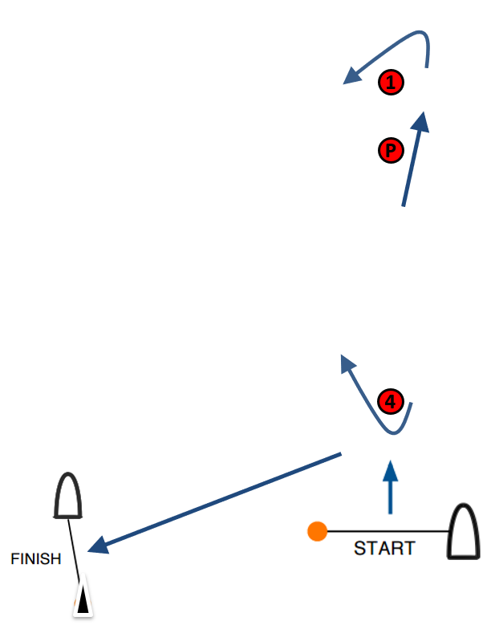

**X 1: Start – Pp – 1p – Pp – 4s – Finish**

**X 2: Start – Pp – 1p – Pp – 4s – Pp – 1p – Pp – 4s – Finish**

**X 3: Start – Pp – 1p – Pp – 4s – Pp – 1p – Pp – 4s – Pp – 1p– Pp – 4s – Finish**

All distances and course angles are approximate.

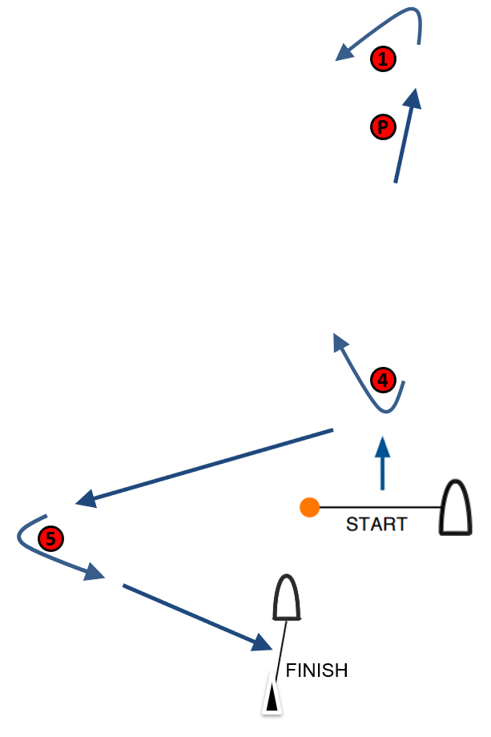

**XS 1: Start – Pp – 1p – Pp – 4s – 5p – Finish**

**XS 2: Start – Pp – 1p – Pp – 4s – Pp – 1p – Pp – 4s – 5p – Finish**

**XS 3: Start – Pp – 1p – Pp – 4s – Pp – 1p – Pp – 4s – Pp – 1p– Pp – 4s – 5p – Finish**

All distances and course angles are approximate.

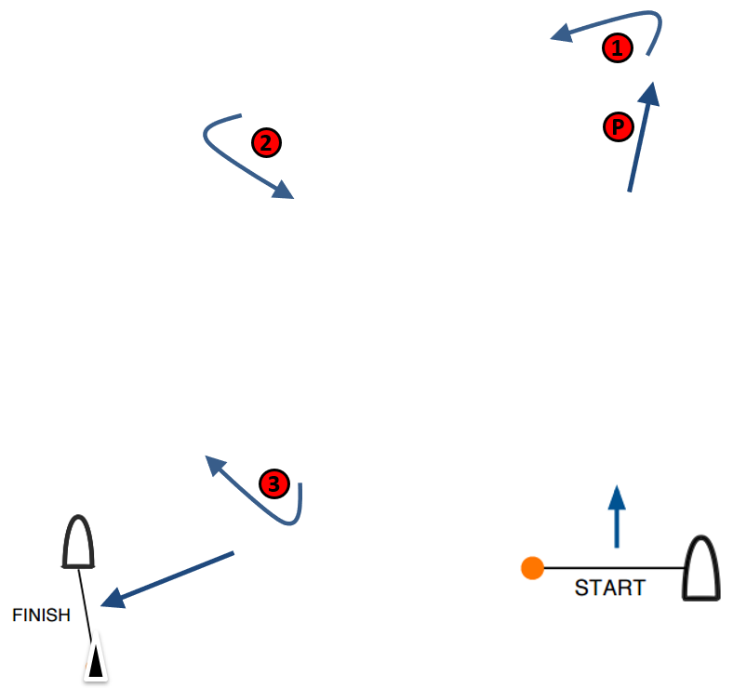

**B 1: Start – Pp – 1p – 2p – 3s – Finish**

**B 2: Start – Pp – 1p – 2p – 3s – 2p – 3s – Finish**

**B 3: Start – Pp – 1p – 2p – 3s – 2p – 3s – 2p – 3s – Finish**

All distances and course angles are approximate.

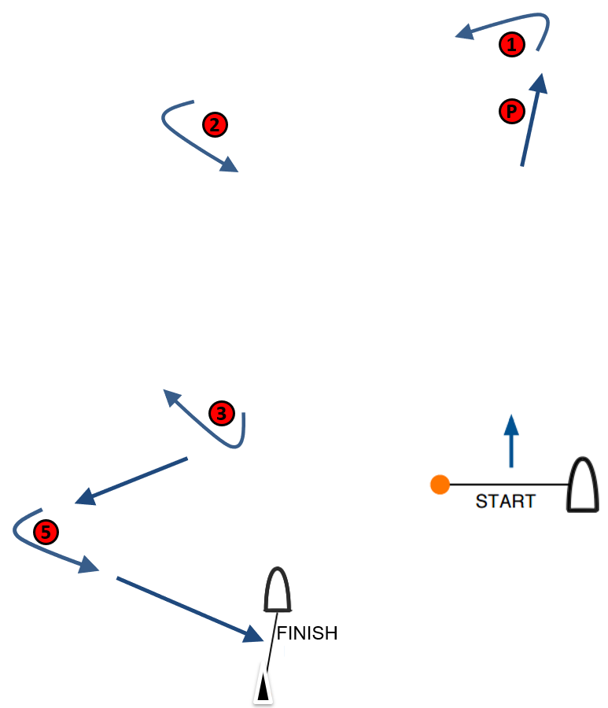

**BS 1: Start – Pp – 1p – 2p – 3s – 5p – Finish**

**BS 2: Start – Pp – 1p – 2p – 3s – 2p – 3s – 5p – Finish**

**BS 3: Start – Pp – 1p – 2p – 3s – 2p – 3s – 2p – 3s – 5p – Finish**

All distances and course angles are approximate.

**ADDENDUM 2**

**SCHEDULE OF RACES**

|  |  |  |  |  |  |  |
| --- | --- | --- | --- | --- | --- | --- |
| **Event Stage** | **[DAY 1]** | **[DAY 2]** | **[DAY 3]** | **[DAY 4]** | **[DAY 5]** | **[DAY 6]** |
|  | Warning Signal | Warning Signal | Warning Signal | Warning Signal | Warning Signal | Warning Signal |
|  | # of races | # of races | # of races | # of races | # of races | # of races |
| **Opening Series** | **[TIME]** | **[TIME]** | **[TIME]** | **[TIME]** | **TIME** |  |
|  | 4 | 4 | 4 | 4 | 4 |  |
| **Qualifying Series** | **[TIME]** | **[TIME]** | **[TIME]** |  |  |  |
|  | 4 | 4 | 4 |  |  |  |
| **Final Series** |  |  |  | **[TIME]** | **[TIME]** |  |
|  |  |  |  | 4 | 4 |  |
| **Golden Ticket Race** |  |  |  |  |  | **[TIME]** |
|  |  |  |  |  |  | 1 |
| **Medal Series** |  |  |  |  |  | **[TIME]** |
|  |  |  |  |  |  | As required |
| **Single Series** | **[TIME]** | **[TIME]** | **[TIME]** | **[TIME]** | **[TIME]** | **[TIME]** |
|  | 4 | 4 | 4 | 4 | 4 | 4 |

[AMEND ACCORDING TO FORMAT, EVENT LENGTH ETC]

**ADDENDUM 3**

**COURSE AREA AND VENUE MAP**

[INSERT INFORMATION AND MAPS]

**ADDENDUM 4**

**OPENING SERIES / GOLDEN TICKET / MEDAL SERIES**

**1 Opening Series**

1.1 The Opening Series may be divided into a Qualifying Series and a Final Series.

**1.2 Qualifying Series (if applicable)**

1. On the first day of racing, kiteboards will be assigned to fleets yellow, blue, red etc., of, as nearly as possible, equal size and ability. Assignments will be made by the race committee and will be posted at least 30 minutes before the first warning signal is made. Those assignments will not be grounds for redress. This changes RRS 61.4(b)
2. Kiteboards will be reassigned to fleets after each day of racing. If all fleets have completed the same number of races, kiteboards will be reassigned based on their ranks in the series. If all fleets have not completed the same number of races, the series scores for reassignment will be calculated for those races, numbered in order of completion, completed by all fleets. For three fleets, and similarly for any other number, reassignments will be made as follows:

First Yellow  
Second Blue  
Third Red  
Forth Red  
Fifth Blue  
Sixth Yellow  
Seventh Yellow  
etc.

1. Reassignments of fleets will be based on the ranking available at 2100 on the day before they take effect, regardless of pending hearings.
2. If all fleets have not completed the same number of races by the end of a day, the fleets with fewer races will continue racing the following day until all fleets have completed the same number of races. All kiteboards will thereafter race in the new fleets.
3. If at the end of the Qualifying Series some kiteboards have more race scores than others, scores for the most recent races will be excluded so that all kiteboards have the same number of race scores.
4. RRS A5.2 is changed so that the scores are based on the number of kiteboards assigned to the biggest fleet.

**1.3 Final Series (if applicable)**

If five or more races are completed by each fleet at the end of the Qualifying Series over a minimum of two days where racing took place:

1. Kiteboards will be assigned to fleets gold, silver, bronze etc., based on their ranking after the Qualifying Series. There will be the same number of fleets in the Final Series as there were in the Qualifying Series. Final Series fleets will have, as nearly as possible, equal size with the following limitations:  
   Gold Fleet: max 25 kiteboards.  
   Silver Fleet: max 30 kiteboards (or remaining kiteboards if two fleets).  
   Bronze Fleet (if applicable): remaining kiteboards.   
   Kiteboards with the best phase Qualifying Series ranks will race all Final Series races in fleet gold, kiteboards with the next-best Qualifying Series ranking will race in fleet silver, etc.
2. Any recalculation of Qualifying Series rankings after kiteboards have been assigned to Final Series fleets will not affect the assignments except that a redress decision may promote a kiteboard to a higher fleet.

c) When breaking ties, only Final Series races shall be considered. If a tie remains, it shall be broken by the kiteboard’s standings in the Qualifying Series. This changes RRS A8.

* + 1. A kiteboard’s Opening Series score will be the total of her race scores except that:
* when from 3 to 6 races have been completed her worst score will be excluded;
* when from 7 to 10 races have been completed her two worst scores will be excluded;
* when 11 or more races have been completed her three worst scores will be excluded;

however, not more than one score from the Final Series may be excluded when less than five Final Series races have been completed, and not more than two scores from the Final Series may be excluded when five or more Final Series races have been completed.   
This changes RRS A2.

1.5 For the Opening Series overall standings, kiteboards will be ranked in the order of the kiteboards competing in fleets gold, silver, bronze, etc. This may not apply to a kiteboard disqualified under RRS 6 or 69.

**2 Golden Ticket Race**

2.1 The Golden Ticket Race will be a Long Distance Race for kiteboards ranked from tenth to last in the Opening Series. The top ranked kiteboard in the Golden Ticket Race will qualify to the Medal Series in 10th place. All other kiteboards are scored according to their rank in their respective Final Series fleets (if any). The score of the Golden Ticket Race shall not be excluded. This changes RRS A4 and A5.

2.2 The race committee may cancel the Golden Ticket Race if the completion of the Medal Series is in jeopardy, or when there are less than 10 entries in an event. In such case, kiteboards ranked 10th in the Opening Series will qualify to the Medal Series in 10th place.

**3 Medal Series**

3.1 The Medal Series will be divided into four stages: Repechage, Quarter-Final, Semi-Final and Grand Final. Kiteboards advance from one stage to the other until the Grand Final.

The race committee may cancel the Repechage, Quarter Final and/or Semi Final stages if the completion of the Medal Series is in jeopardy, or when there are less than 10 entries in an event or gender. In such case, competitors ranked or seeded first and second in the previous stage advance to the next stage

3.2 The first ranked kiteboard in the Opening Series will qualify to the Grand Final carrying forward two match points.

3.3 The second ranked kiteboard in the Opening Series will qualify to the Grand Final carrying forward one match point.

3.4 The third and fourth-ranked kiteboards in the Opening Series will qualify to the Semi-Final.

3.5 The fifth and sixth-ranked kiteboards in the Opening Series will qualify to the Quarter-Final.

3.6 Kiteboards ranked seventh to ninth in the Opening Series and the winner of the Golden Ticket Race will qualify to the Repechage Race.

3.7 The top two ranked kiteboards from the Repechage Race qualify to the Quarter-Final.

3.8 The top two ranked kiteboards from the Quarter-Final qualify to the Semi-Final

3.9 The top two ranked kiteboards from the Semi-Final qualify to the Grand Final.

3.10 If there is a tie between two kiteboards, they will be ranked in order of their positions in the previous stage.

3.11 Grand Final

3.11.1 The Grand Final will continue until one kiteboard collects three match points. The kiteboard with the lowest race score collects a match point.

3.11.2 Kiteboards in the Grand Final will be ranked in order of the number of match points, from highest to lowest.

3.11.3 If there is a tie in match points between two or more kiteboards, they will be ranked in the order of their finishing positions in the last race. Any remaining ties shall be broken by using the tied kiteboards’ scores in the next-to-last finals race and so on. If a tie remains, they will be ranked in order of their opening series ranking.

This changes RRS A8

3.12 The winner of the Grand Final is the winner of the event. All others are ranked as follows:

|  |  |
| --- | --- |
| Event Rank |  |
| 1 | 1st place Grand Final |
| 2 | 2nd place Grand Final |
| 3 | 3rd place Grand Final |
| 4 | 4th place Grand Final |
| 5 | 3rd place Semi-Final |
| 6 | 4th place Semi-Final |
| 7 | 3rd place Quarter-Final |
| 8 | 4th place Quarter-Final |
| 9 | 3rd place Repechage Race |
| 10 | 4th place Repechage Race |

If the Grand Final is not completed, competitors will be ranked in positions 1-4 according to the current standing of the Grand Final.

3.13 If a stage cannot be completed, competitors are ranked in the order of their finishing position in the previous stage. If the Repechage Race cannot be completed, competitors in the Repechage Race are ranked in the order of their position after the Opening Series.

3.14 Kiteboards not qualified for the Medal Series will be ranked after the kiteboards qualified for the Medal Series, according to their Opening Series score plus their Golden Ticket race score in their respective fleets. This changes RRS A2.

3.15 Kiteboards in the Medal Series will be ranked in front of the remaining kiteboards competing in the gold fleet, which will be ranked in front of kiteboards competing in subsequent fleets etc. This may not apply to a kiteboard disqualified under RRS 6 or 69.

**4 Scores in the Medal Series determined by the race committee.**

4.1 A kiteboard that came to the starting area but did not start or did not finish will be scored points for the finishing place one more than the number of kiteboards that finished and were not disqualified or retired.  
This changes RRS A5.

**ADDENDUM 5**

**SINGLE SERIES**

1. Single Series

The Single Series may be divided into a Qualifying Series and a Final Series.

1.1 When there is a Final Series, it will be scheduled for the two last racing days.

1.2 Qualifying Series (if applicable):

1. On the first day of racing, kiteboards will be assigned to fleets yellow, blue, red etc., of, as nearly as possible, equal size and ability. Assignments will be made by the race committee based on the kiteboards’ current standing in the world ranking and will be posted at least 30 minutes before the first warning signal is made. Those assignments will not be grounds for redress. This changes RRS 62.1(a).
2. Kiteboards will be reassigned to fleets after each day of racing, except if only one race is completed. If all fleets have completed the same number of races, kiteboards will be reassigned on the basis of their ranks in the series. If all fleets have not completed the same number of races, the series scores for reassignment will be calculated for those races, numbered in order of completion, completed by all fleets. For three fleets, and similarly for any other number, reassignments will be made as follows:

First Yellow  
Second Blue  
Third Red  
Forth Red  
Fifth Blue  
Sixth Yellow  
Seventh Yellow  
etc.

1. Reassignments of fleets will be based on the ranking available at 2100 on the day before they take effect, regardless of pending hearings.
2. If all fleets have not completed the same number of races by the end of a day, the fleets with fewer races will continue racing the following day until all fleets have completed the same number of races. All kiteboards will thereafter race in the new fleets.
3. If at the end of the Qualifying Series some kiteboards have more race scores than others, scores for the most recent races will be excluded so that all kiteboards have the same number of race scores.
4. RRS A5.2 is changed so that the scores are based on the number of kiteboards assigned to the biggest fleet.

1.3 If 5 or more races are completed over a minimum of two days on which racing took place by each fleet at the end of the Qualifying Series:

1. Kiteboards will be assigned to fleets gold, silver, bronze etc., based on their Qualifying Series ranking. There will be the same number of fleets in in the Final Series as there were in the Qualifying Series. The Final Series fleets will have, as nearly as possible, equal size and the Gold fleet will not be smaller than any other fleet. Kiteboards with the best Qualifying Series ranks will race all Final Series races in fleet gold, kiteboards with the next-best Qualifying Series ranking will race in fleet silver, etc.
2. Any recalculation of rankings after kiteboards have been assigned to Final Series fleets will not affect the assignments except that a redress decision may promote a kiteboard to a higher fleet.
3. When breaking ties, only Final Series races shall be considered. If a tie remains, it shall be broken by the kiteboard’s standing at the end of the Qualifying Series. This changes RRS A8.

1.4 A kiteboard’s Opening Series score will be the total of her race scores except that:

* when from 3 to 6 races have been completed her worst score will be excluded;
* when from 7 to 10 races have been completed her two worst scores will be excluded;
* when 11 or more races have been completed her three worst scores will be excluded;

however, not more than one score from the Final Series may be excluded when less than five Final Series races have been completed, and not more than two scores from the Final Series may be excluded when five or more Final Series races have been completed.   
This changes RRS A2.

1.5 When there is a Final Series, kiteboards will be ranked in the order of the kiteboards competing in fleets gold, silver, bronze, etc. This may not apply to a kiteboard disqualified under RRS 6 or 69.